PROVISIONAL PATENT APPLICATION

EXCELERATE TEST PREP

Author: Amit Patankar

BACKGROUND

Field of the Invention: Data Analytics on Standardized Test Performance

The present invention is directed to apply data analysis algorithms on standardized test practice tests to predict, find, and exploit vulnerabilities of students taking any standardized test.

Description of the Related Art:

The revision 1.0 of Excelerate is complete. The product is able to create an answer sheet based upon a directory of test data given by test centers, grade a student's test, and save the results. It also is able to run data analysis and make predictions for each user.

SUMMARY
Objectives:

- To maximize the learning efficiency for students studying for standardized tests.
- To help students understand and exploit their real vulnerabilities rather than using a brute force method.

BRIEF DESCRIPTION OF THE DRAWINGS

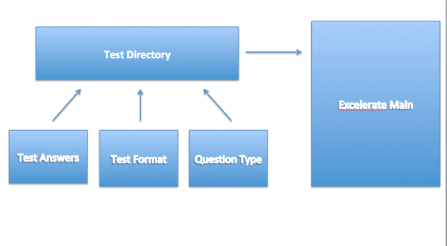
Figure 1

- Figure 1 represents the way Excelerate stores data regarding a practice test from a test center. A test center inputs the test format, question types, and corresponding answers in our format guidelines or using a prompt and Excelerate stores that tests. Tests are indexed by a 4 digit code.

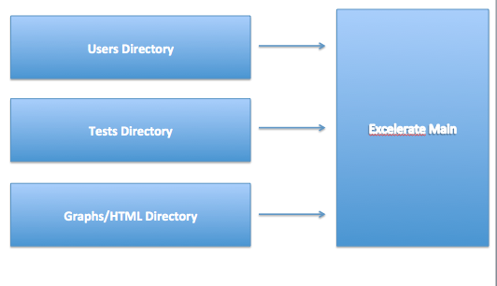
Figure 2

- Figure 2 represents the main directories that are imported on a normal call to the Excelerate program. It imports the user data from the Users directory, the tests from the Tests directory, and additional information for reports from the Graphs and HTML directory.

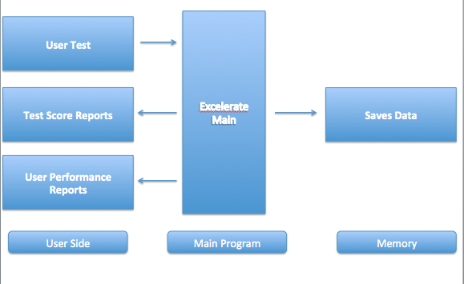
Figure 3
- Figure 3 represents the overall flow of Excelerate software. A user inputs an answered test and Excelerate will grade the test and return the test score report. Then after saving the data, Excelerate will run data analysis and return performance reports.

DETAILED DESCRIPTION
Excelerate software uses a very unique method and approach to providing data analytics. Tests are inputted via guidelines into our Test directory in the application. Users are also created and loaded via a Users directory. When requested, Excelerate is able to create a answer sheet in a clean CSV file according and tailored to the test code it was requested for in the user's corresponding directory.

Loading and saving mechanisms are quite unique to Excelerate. Whenever a question is answered, it is given a code that corresponds to its test code, section, and question index number. Whenever a student grades a test, their file is appended with missed and blank question codes and the corresponding answer. When reloading a user, the application parses through the vast list of questions, looks up the code for each missed and blank question, assumes all other questions are correct and recreates the score and answer sheet for each test internally to run analysis on. All tests are kept in order too to plot a chronological pattern.

Excelerate has custom advice and analysis word banks that randomly select advice and encouragement based upon performance. Advice is color-coded so it can be easily understood. Excelerate also has a college tracker functionality that allows a user to see their scores in comparision to average applicant scores to any school. It also has 5 unique reports that give varying levels of data and analysis in case a test center wants to charge deterministically per report.

Excelerate has a user limit license and a date expiration license as well.

CLAIMS

- Data analysis over time of various input practice tests to find patterns in weaknesses or strengths and other various trends.
- Saving and loading a test based upon a list of missed questions from an answer sheet.
- Application of various statistical models and algorithms to monitor fatigue, inconsistency, and other vulnerabilities.
- Ability to import tests from a test center and create answer sheets, grade tests, and save test performance.
- Application of question "type" and difficulty search codes that allow users to categorize questions to see any glaring vulnerability in any question type or level of difficulty.

